Homework 4 – Lanz Compala

1. Give at least 2 reasons why the Delete statement should not be used.  
Answer:  
- Most of the time there is no reason to delete data from a database. Obsolete or unused data will be stored as historical data. Deleting historical records may cause issues due to dependencies and can cause applications to crash  
- Delete statement can corrupt data if performed without proper knowledge of the database such as relationships or how data works together. Performing delete statement without proper knowledge can permanently lose data not intended to be deleted.

3. Can the Select Into command be used when selecting from multiple tables? Why or why not? What issues might occur?  
Answer:  
- Yes. Selecting columns from multiple tables using Select Into command allows to choose relevant columns to include in the temp table. Once a temp table is created, data can be manipulated without affecting the database. An issue might occur when temp tables are overused. It slows down the dataset as it creates and maintains each temp table each time a query is executed.

9. How did you find which item would cause the FlaggedForReview column to be marked 1?  
Answer: By looking at the Triggers of OrderLookup table. In FlagOrders trigger it shows which ProductId will set FlaggedForReview to 1.  
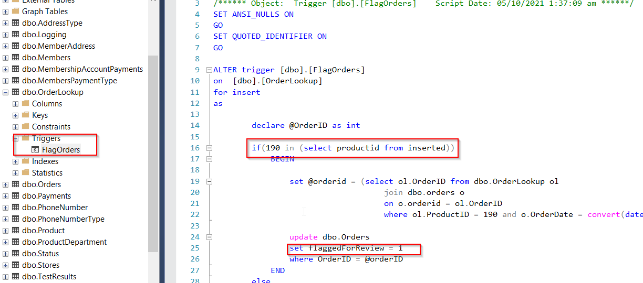

12. Explain why a Dynamic Pivot Table might be preferential over a Static Pivot Table. Give at least one example.   
Answer:  
Dynamic Pivot table is preferred due to its flexible nature. Since its data is retrieved on runtime it gathers the latest and updated values in the query. Columns can also be updated either by parameter or based on the set query in the procedure. An example of dynamic pivot table is when retrieving the number of orders placed per year. Columns can be set to accept parameter of desired year to display or set to display all years including the current year.